AI Assisted coding
Lab Test - 1
Name:J.rohith Id: 2403A510f1
Batch: 05 Date: 01-09-2025
Q1. Zero-shot Classification [5M]
• Scenario: Classify tweets into “Positive,” “Negative,” or “Neutral.”
• Task 1: Write a zero-shot prompt to classify sentiment without any examples.
• Task 2: Create a scenario where an AI assistant needs to help a student solve math problems.
Task - 1:
Prompt:
“Classify the following tweet as “Positive,” “Negative,” or “Neutral” based on its sentiment using a python Code.”
Tweet: "I just got a new job and I’m so excited!"
Code Generated:
def classify_tweet_sentiment(tweet):
positive_words = ["excited", "happy", "love", "great", "good", "cool", "amazing", "wonderful", "joy", "awesome", "fantastic", "best", "success"]
negative_words = ["sad", "angry", "bad", "hate", "terrible", "upset", "disappointed", "worst", "fail", "awful", "horrible", "problem"]

tweet_lower = tweet.lower()

if any(word in tweet_lower for word in positive_words):
return "Positive"
elif any(word in tweet_lower for word in negative_words):
return "Negative"
else:
return "Neutral"

tweet = input("Enter a tweet to classify its sentiment: ")
sentiment = classify_tweet_sentiment(tweet)
print(f'Tweet: "{tweet}"\nSentiment: {sentiment}')

Code Image:
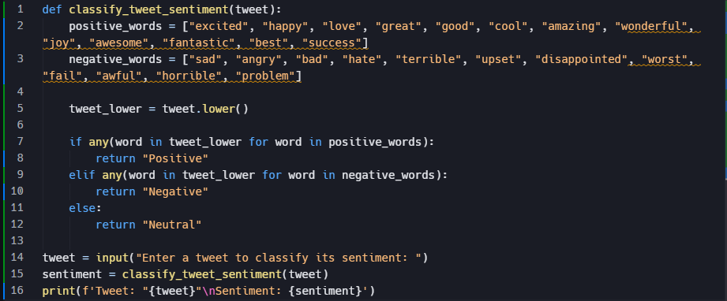

Output:
- Positive tweet
- Negative tweet
- Neutral tweet

Observation:
- The program attempts by checking for keywords related to positive and negative emotions.
- For the input tweet: "I just got a new job and I’m so excited!"
- the algorithm finds the word “excited” in the positive word list.
- Since positive words are detected and no negative words appear, the classifier correctly predicts: Positive
Task – 2:
Prompt Without Context:
Help the student solve the following math problem:
"What is 7 multiplied by 8?" using c programming language
Code Generated:
#include <stdio.h>
int main() {
int a, b, result;
printf("Enter the first number: ");
scanf("%d", &a);
printf("Enter the second number: ");
scanf("%d", &b);
result = a * b;
printf("What is %d multiplied by %d?\n", a, b);
printf("Answer: %d\n", result);
return 0;
}
Code Image:
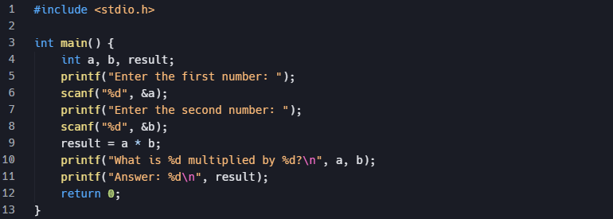

Output:

Prompt With detailed Context:
“You are an AI assistant helping a 6th-grade student with math homework. The topic is multiplication, and the difficulty level is basic.”
Code Generated:
#include <stdio.h>

int main() {
int a = 7, b = 8, result;
printf("You are a 6th-grade student learning multiplication.\n");
printf("Let's solve: What is %d multiplied by %d?\n\n", a, b);
printf("Step 1: Write the numbers: %d and %d.\n", a, b);
printf("Step 2: Multiply them together.\n");
printf("%d x %d = ", a, b);
result = a * b;
printf("%d\n", result);
printf("So, %d multiplied by %d equals %d.\n", a, b, result);
printf("Multiplication means adding %d eight times: ", a);
for(int i = 1; i <= b; i++) {
printf("%d", a);
if(i < b) printf(" + ");
}
printf(" = %d\n", result);
printf("Great job!\n");
return 0;
}

Code Image:
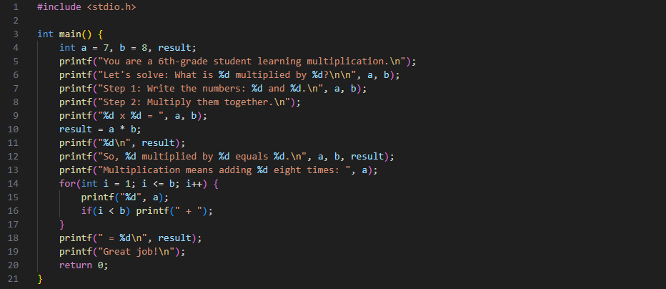

Output:
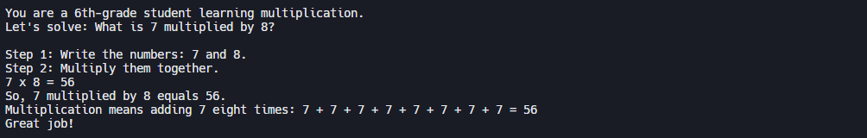

Observation:
The program calculates the product of two user-inputted numbers but presents the output in a peculiar way. Instead of simply stating the result, it first poses a question to the user, "What is [first number] multiplied by [second number]?," and then immediately provides the answer. This suggests the program is designed to be interactive or to simulate a quiz, even though it provides the solution right after the question. The variable result stores the correct answer, which is then printed to the console. The code is functionally correct for its purpose, but the order of the printf statements makes the interaction a bit unusual.

